**Student loan Complaints**

Histogram Score

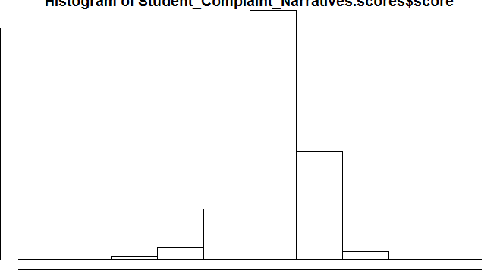

Hisogram Score (QPlot)

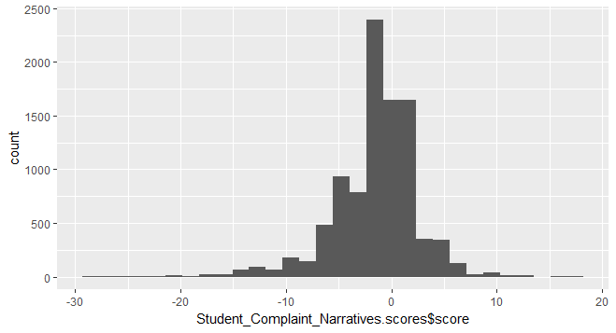

Hisogram Score (ggplot2)

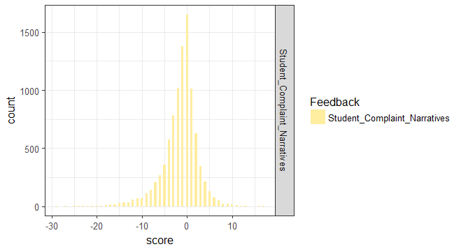

Sentiment Analysis of Students' complaints (classification by polarity)

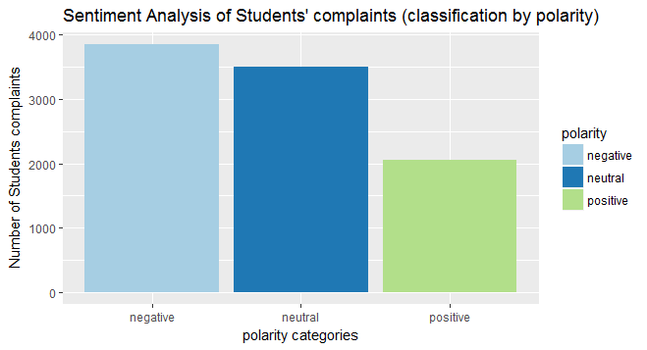

Sentiment Analysis of Students' complaints (classification by emotion)

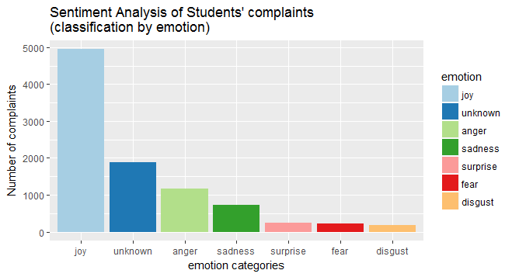

Pie Chart with size (polarity)

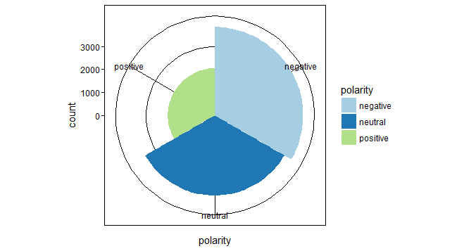

Pie Chart with size (emotion)

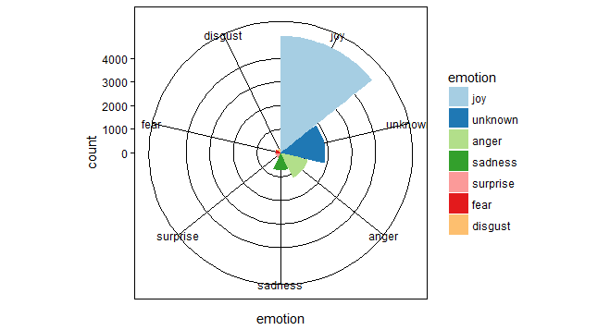

Pie Chart (polarity)

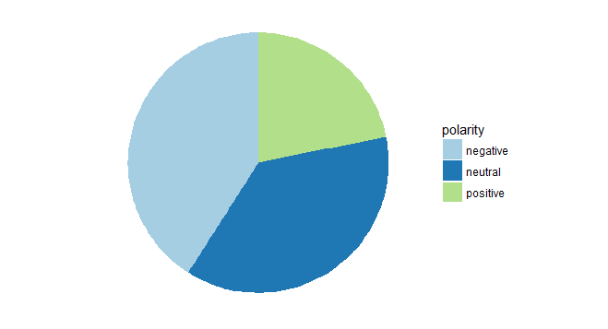

Pie Chart (emotion)

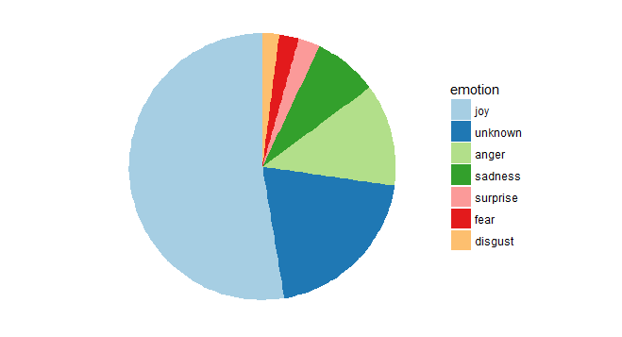

Word cloud non-ajustement (Student Loan entirely)

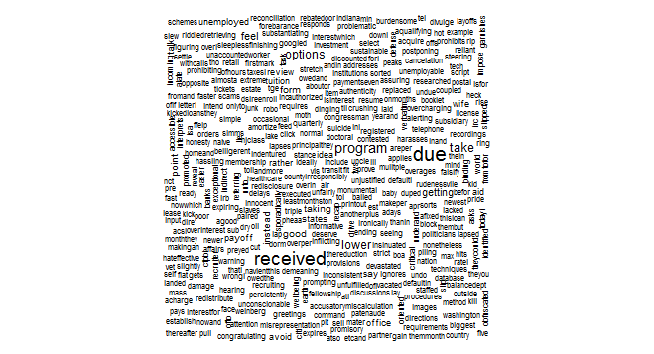

Word cloud ajusted

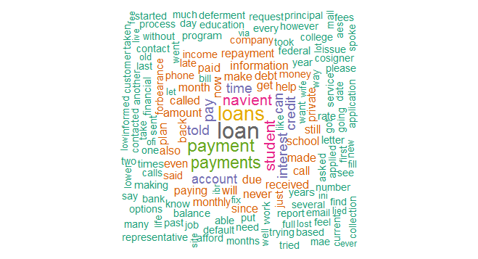

Word Cloud comparaison based on emotion

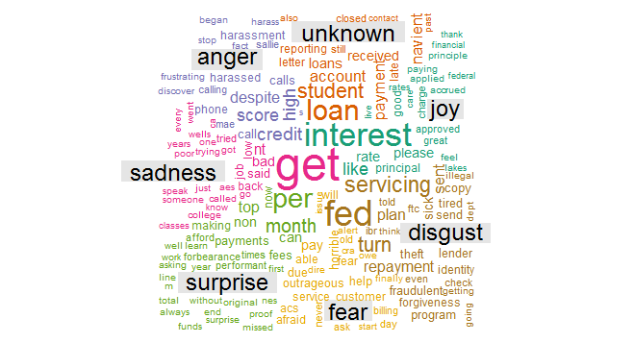

Word Cloud comparaison based on polarity

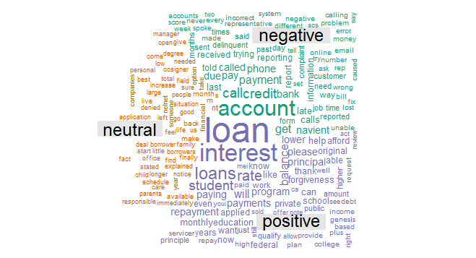

Word Cloud comparaison based on polarity (max.Word = 3000)

